DAY 2 – 10.04.2024

LEETCODE PROBLEM SOLUTION SUBMISSION

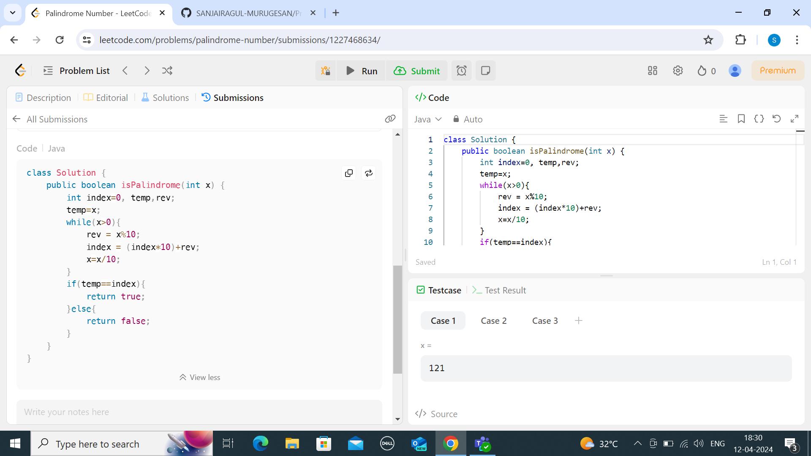

* WORKED ON GITHUB PUSH, PULL, MERGE, BRANCH.